FINAL PROJECT COMPLETION REPORT

I. BASIC DATA

Organization Name: Psoriasis Association of Kenya
Project Title: Psoriasis Association of Kenya Easter Symposium & Online Psoriasis Awareness Campaign
Date of Report: May 2022
Report compiled by: Tina Ochsner

II. OPENING REMARKS

Abbreviations
PAK - Psoriasis Association of Kenya
IFPA – International Federation of Psoriatic disease Associations

PAK is the recipient of IFPs 2022 Solidarity Fund. Funds were used to create -The Easter Symposium & Online Psoriasis Awareness Campaign. The main target being psoriasis patients and care givers. The online campaign focused on raising awareness around psoriasis, advocating not to discriminate patients living with the condition and educate on the condition not being contagious.

Thereafter the symposium created a safe space to share experiences of living with the condition and provide the opportunity to interact with medical practitioners.

Problem Addressed: psoriasis is not a well-known disease in Kenya. A lot of myths and taboos beliefs surround the condition.

III. ACHIEVEMENT OF PROJECT PURPOSE

Project Purpose: Equipping patients and care givers with knowledge of the condition whilst empowering the greater public on the condition.

Planned vs. Actual Performance

Indicator | Actual at Completion
Purpose-level:
1. Education series: Target 1000 patients, care givers and medical practitioners on social media. | Achieved. Period 1st March – 1st April 2022  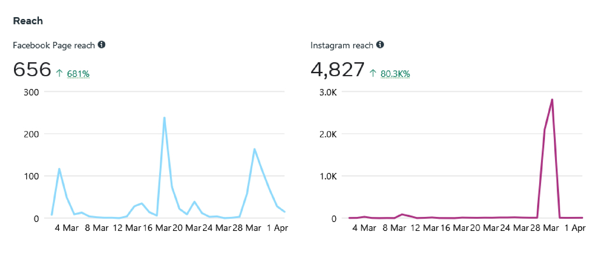
2. 5 psoriasis patients from different races/ethnicities/religions/age/gender/ demographics to showcase that psoriasis doesn’t choose | Achieved. Annex 1 content social media report
3. Advocacy Series: To empower patients, caregivers and the general public on the condition | Achieved. Annex 1 content social media report
4. Share your story: To give hope on living with psoriasis | Achieved. Annex 1 content social media report
5. Easter Symposium: Invite PAK members | Achieved. Annex 2 meeting minutes

Were there any unexpected impacts (positive or negative)?
The leverage of the Easter Symposium has been very large. Through the program, PAK was able to build a new website, new social media accounts and lay the foundation for future advocacy works.

IV. PROJECT OUTPUTS

Planned vs. Actual Performance

Indicator | Actual at Completion
Output 1:
1. To have 50 patients and care givers attend the symposium. A minimum of 5 can contribute to the campaign to share stories of being a Psoriasis caregiver and share tips to encourage other Psoriasis caregivers. | Actual turnout for both 2 meetings held between March and April 2022 was 24 patients and care givers. Stories contributed by 7 members. See Annex 3 attendance sheet.
2. Target a minimum of 5 media houses to cover the in both English, Swahili and a few vernacular languages to tell empowering stories about Psoriasis. | Actual interest expressed by 1 media house - BBC Life clinic. Interview is published on their website: https://www.bbc.co.uk/programmes/p0cb6wdv
3. To teach a wider population about psoriasis in bid to end stigmatization and increase awareness. | Actual reach 2000 people including website, social media and PAK forums.
4. Education on living a quality and productive life even with psoriasis | This was successful. The main message shared ‘there is hope’.
4. 4 doctors to share stories of tips from science, nature and psychology that can empower patients. Provide tips to identify person-centred care healthcare practitioners and establishments so that their medical outcomes are improved. Information about hospitals that can help patients have access to dermatologists and adequate support services and medicine can help as not all hospitals and counties are adequately equipped to handle Psoriasis adequately. | Actual medical practitioners participated were 1 doctor and 1 nurse. They spoke to PAK members during the symposium, sharing latest findings and educational tips on living with the psoriasis.

Online Campaign | Period March – April 2022
Output 2:
1. To have psoriasis campaign materials reach 1050 people. | Achieved. In this period PAK Facebook and Instagram had a cumulative content reach of 6881. See Annex 1.
2. To target 100 people to join online patient support group (PAK) | Achieved. PAK WhatsApp group has now 179 active members.
Output 3:
- Increased awareness on the condition  - Increased community feel  - Dispersion of myths and taboos related to psoriasis. | Achieved. Members shared their stories and gave hope to new members.

Output 4:
- Improved availability and accessibility to medical practitioners  - Improved lifestyle habits  - Improved knowledge on the condition  - Increased enrolment of PAK membership  - Increased support and mentorship  - Reduced suffering and exploitation of patients | Achieved at two levels. Through the meetings, PAK members shared their stories on living with psoriasis, with the guidance of medical practitioners’ tips were shared on lifestyle habits and knowledge of the condition. The trickledown effect was increased enrolment of PAK membership and reduced suffering. The message reiterated being ‘there is hope’.
End-of-project audit shows that funds were fully spent on their agreed purposes | Funds fully spent on agreed purposes.

Describe the success of the project in terms of delivering the intended outputs.
The project was highly successful in delivering its outputs. It was created and led by PAK members.

Were any outputs unrealized? If so, how has this affected the overall impact of the project?
Output 1: 1 The project was not able to realize this output to its full potential. Some of the factors hindering the project success was availability of patients & care givers to attend the meetings. The meetings were split into two to give attendees opportunities to attend. Unfortunately, most sent their apologies due to unforeseen circumstance/job commitments. The success of the online campaign balanced out the low attendance rate and lead to the overall success of the project.
Output 1: 2 Media houses were initially not open to air psoriasis related news. Their main storyline interest being politics as it is an election year. Only 1 media house expressed interested in telling the story what is psoriasis. BBC Life Clinic: https://www.bbc.co.uk/programmes/p0cb6wdv

Lessons learnt in the project.
The enrolment of new members, growth of social media platforms showed there is a high demand for knowledge on psoriasis.
Patients and caregivers were meaningfully involved in addressing matters affecting them, their voice and opinions were sought and their solutions to the problems they face considered. Actively engaging PAK members to volunteer proved that such projects can again be successfully implemented in future by members.

VI. Return on Investment

Describe the project’s return on investment.
PAK membership is open to all patients, care givers and health workers in Kenya. Members are only encouraged to pay an annual membership fee. Membership status is not revoked due to non-payment.
In this period, the enrolment of non-paying PAK members increased significantly. This showed the value of the project brought in a high social return on investment (SROI).

